**LAB #09**

**Routing Protocol**

Configuring RIP (Routing Information Protocol)

**Theory:**

**Routing Information Protocol:**

RIP is a standardized Distance Vector protocol, designed for use on smaller networks. RIP was one of the first true Distance Vector routing protocols, and is supported on a wide variety of systems.

RIP adheres to the following Distance Vector characteristics:

* RIP sends out periodic routing updates (every 30 seconds) 
* RIP sends out the full routing table every periodic update 
* RIP uses a form of distance as its metric (in this case, hop count) 
* RIP uses the Bellman-Ford Distance Vector algorithm to determine the best 

“path” to a particular destination

* RIP supports IP and IPX routing. 
* RIP utilizes UDP port 520 
* RIP routes have an administrative distance of 120. 
* RIP has a maximum hop count of 15 hops. 

Any network that is 16 hops away or more is considered unreachable to RIP,

thus the maximum diameter of the network is 15 hops. A metric of 16 hops in RIP is considered a poison route or infinity metric.

RIP has two versions, Version 1 (RIPv1) and Version 2 (RIPv2).

RIPv1 (RFC 1058) is classful, and thus does not include the subnet mask with

its routing table updates. Because of this, RIPv1 does not support Variable Length Subnet Masks (VLSMs). When using RIPv1, networks must be contiguous, and subnets of a major network must be configured with identical subnet masks. Otherwise, route table inconsistencies (or worse) will occur.

RIPv2 (RFC 2543) is classless, and thus does include the subnet mask with its routing table updates. RIPv2 fully supports VLSMs, allowing discontiguous networks

and varying subnet masks to exist.

Other enhancements offered by RIPv2 include:

* Routing updates are sent via multicast, using address 224.0.0.9 
* Encrypted authentication can be configured between RIPv2 routers 
* Route tagging is supported (explained in a later section).their networks to match the functional and security requirements of their systems without having to run

new cables or make major changes in their current network infrastructure. 

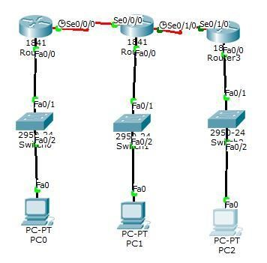

**Procedure:**

**Step1:**

The topology consists of 3 Cisco routers which are connected with each other and also with 3switches and switches are connected with 3PCs **Step 2:**

A WIC-1T card is placed in the slots in each router. Switch off the router and place the card in the slots and turn it on again. One end of the cable is DTE and the other is automatically DCE.

**Step 3:**

We have total 5 networks , now assign ip to each network, assign first three ip in pc using default gateways: 192.168.1.1, 192.168.2.1, 192.168.3.1and remaining two on the serial

interface of router.

**Step 4:**

Now configure fast Ethernet and serial interface of router by using CLI. Configuration of R0 are as follow:

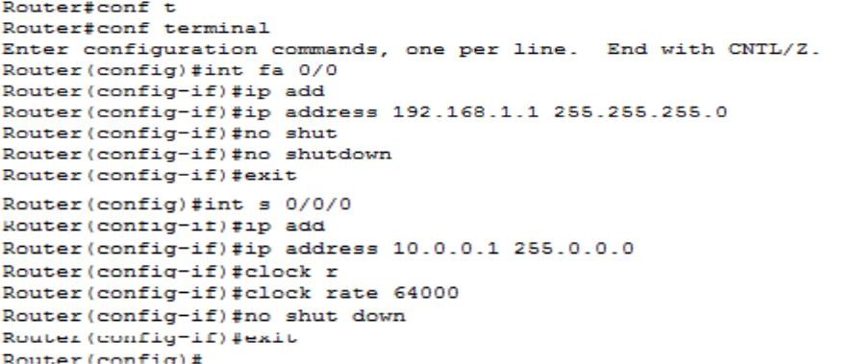

**Step 5:**

Enabling RIP **:**

By using following commands:

* + Router rip 
  + Network ip address 

Enable a RIP routing process, which places you in router configuration mode. And associate the networks with a RIP routing process. Then enter the command **show ip route** on Ro, R1 and R2 to verify that the new route is now in the routing table.

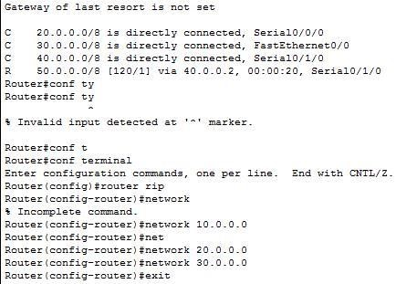

**Exercises:**

**Q1.** What is RIP what is the use of RIP?.

The Routing Information Protocol (**RIP**) is one of the oldest distance-vector routing protocols which employs the hop count as a routing metric. **RIP** prevents routing loops by implementing a limit on the number of hops allowed in a path from source to destination.

**Q2.** How do we configure RIP?

Configuring RIP requires the following steps:

1. **Step 1**Enable the RIP routing process, which places you in router configuration mode via the Router#**router rip** command.
2. **Step 2**Specify those networks that should be advertised using RIP via the Router(config-router)#**network** [*network-number*] command.

**Q3** On which basis RIP decides the best path (routing metric)?

**RIP chooses** a **path** based on hop count, whereas EIGRP **chooses** a **path** based on its composite **metric**.

**Q.4** What is the maximum Hop count for RIP is?

The **maximum hop count for RIP** routers is 15. Networks with a **hop count** of 16 or more are considered unreachable.

**Q.**5 In how many seconds RIP end the routing updates to adjacent routers.

A **RIP router** broadcasts **routing** information to its directly connected networks every 30 **seconds**. It receives **updates** from **neighboring RIP routers** every 30 **seconds** and uses the information contained in these **updates** to maintain the **routing** table.

**Q.6 W**hat protocol did RIP uses ?

**RIP uses** the User Datagram **Protocol** (UDP) as its transport **protocol**, and is assigned the reserved port number 520.

**Q.7** What is the difference between RSTP & STP?

The differences between Spanning Tree Protocol (STP), Rapid Spanning Tree Protocol (RSTP) are as follows:  
STP: only supports a single instance.  
RSTP: supports fast convergence and a single instance.

**Q.8** Is STP by default configure in cisco switch?

**STP** is typically configured when there are redundant links to a host to prevent network loop.

Sir Syed University of Engineering and Technology

(Department of Computer Science & Information Technology) Page 4